**GAP Errors**

* More than one document is not showing in Plant Protection Product.

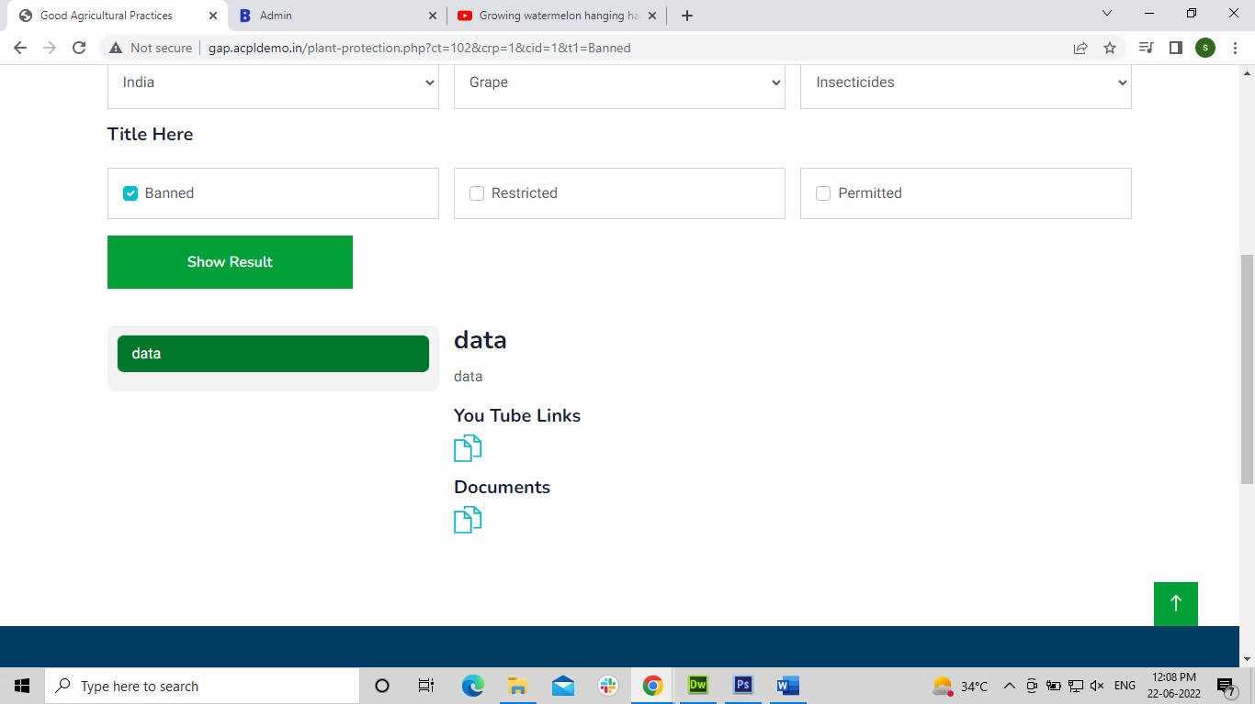

* Documents are not showing in view list in Plant Nutritional Management.

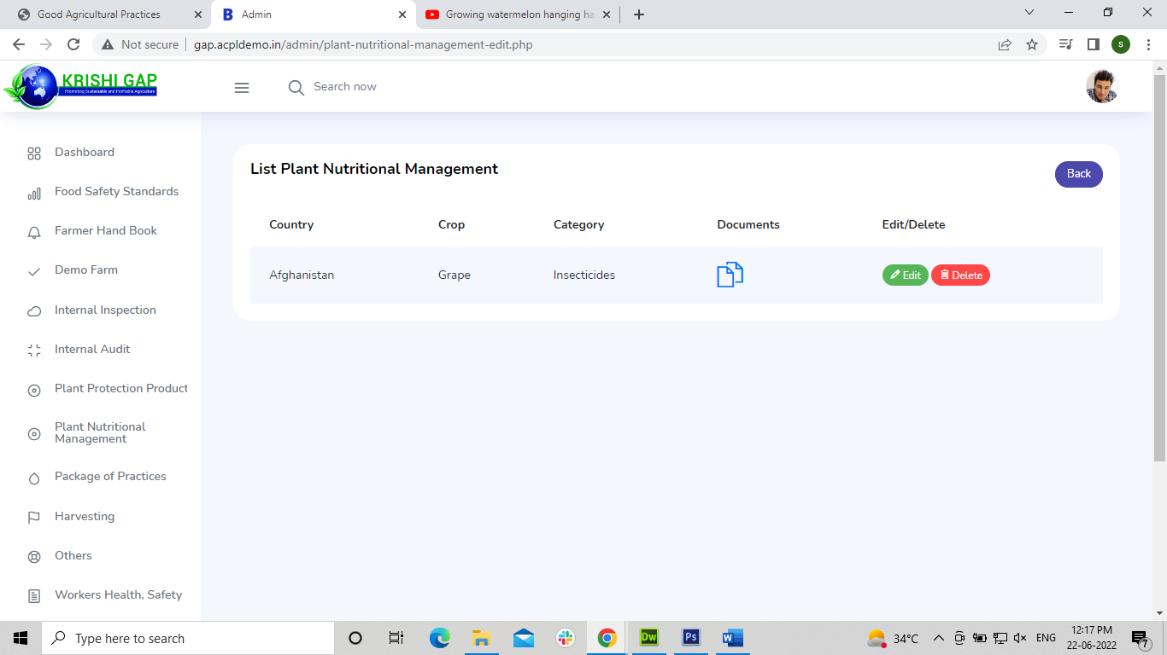

* More than one document is not showing in Plant Nutritional Management.

